**LAB CYCLE 1**

**1. Program to Print all non-Prime Numbers in an Interval.**

**Code:**

print("Name:Annjish Kunjumon")

print("Reg no: SJC22MCA-2009")

print("Batch:2022-2024")

lower_value=int(input("Enter the Lowest Range value:"))

upper_value=int(input("Enter the upper Range value:"))

print("The non-prime numbers in range are:")

for number in range (lower_value,upper_value + 1):

if number > 1:

is_prime = True

for i in range(2, number):

if (number % i) == 0:

is_prime = False

break

if not is_prime:

print(number)

**Output:**

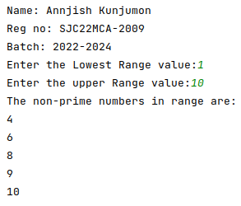

**2. Program to print the first N Fibonacci numbers.**

**Code:**

print("Name: Annjish Kunjumon")

print("Reg no: SJC22MCA-2009")

print("Batch: 2022-2024")

n= int(input("Limit of series:\n"))

a=0

b=1

count=0

if(n <= 0):

print("Invalid input..")

else:

print("Fibonacci Series.....")

while(count < n):

print(a)

next=a+b

a=b

b=next

count=count+1

**Output:**

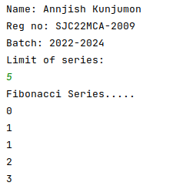

**3. Given sides of a triangle, write a program to check whether given triangle is an**

**isosceles, equilateral or scalene.**

**Code:**

print("Name: Annjish Kunjumon")

print("Reg no: SJC22MCA-2009")

print("Batch: 2022-2024")

print("Input length of Triangle Sides:")

x=int(input("x:"))

y=int(input("y:"))

z=int(input("z:"))

if( x == y == z):

print("Equilateral triangle")

elif(x == y or y==z or z==x):

print("Isosceles triangle")

else:

print("Triangle is Scalene")

**Output:**

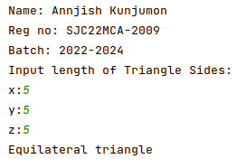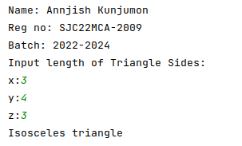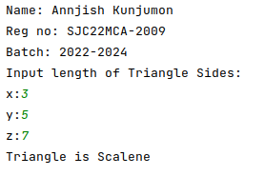

**4. Program to check whether given pair of number is coprime.**

Code:

import math

def are_coprime(a, b):

gcd = math.gcd(a, b)

return gcd == 1

print("Name: Annjish Kunjumon")

print("Reg no: SJC22MCA-2009")

print("Batch: 2022-2024")

print("-----------------------")

num1 = int(input("Enter the first number: "))

num2 = int(input("Enter the second number: "))

if are_coprime(num1, num2):

print(f"{num1} and {num2} are coprime.")

else:

print(f"{num1} and {num2} are not coprime.")

**Output:**

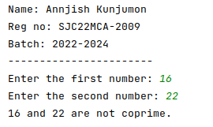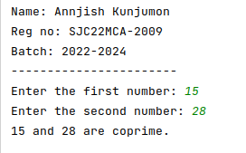

**5. Program to find the roots of a quadratic equation(rounded to 2 decimal places)**

**Code:**

print("Name: Annjish Kunjumon")

print("Reg no: SJC22MCA-2009")

print("Batch: 2022-2024")

print("-----------------------")

import math

a = float(input("Enter value of a: "))

b = float(input("Enter value of b: "))

c = float(input("Enter value of c: "))

discri = b**2 - 4*a*c

if discri > 0:

root1 = (-b + math.sqrt(discri)) / (2*a)

root2 = (-b - math.sqrt(discri)) / (2*a)

print(f"Root 1: {round(root1, 2)}")

print(f"Root 2: {round(root2, 2)}")

elif discri == 0:

root = -b / (2*a)

print(f"Root: {round(root, 2)}")

else:

real_part = -b / (2*a)

img_part = math.sqrt(-discri) / (2*a)

root1 = complex(real_part, img_part)

root2 = complex(real_part, -img_part)

print(f"Root 1: {root1.real:.2f} + {root1.imag:.2f}i")

print(f"Root 2: {root2.real:.2f} - {root2.imag:.2f}i")

**Output:**

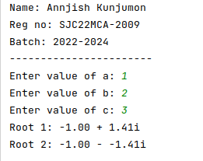

**6. Program to check whether a given number is perfect number or not(sum of factors=number)**

**Code:**

def is_perfect_number(num):

if num <= 0:

return False

sum_of_divisors = 0

for i in range(1, num):

if num % i == 0:

sum_of_divisors += i

return sum_of_divisors == num

try:

print("Name: Annjish Kunjumon")

print("Reg no: SJC22MCA-2009")

print("Batch: 2022-2024")

print("-----------------------")

num = int(input("Enter a number: "))

if is_perfect_number(num):

print(f"{num} is a perfect number.")

else:

print(f"{num} is not a perfect number.")

except ValueError:

print("Invalid input. Please enter a valid number.")

**Output:**

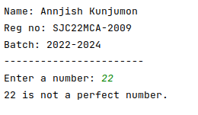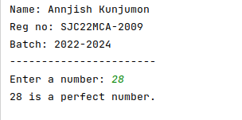

**7. Program to display armstrong numbers upto 1000.**

**Code:**

print("Name: Annjish Kunjumon")

print("Reg no: SJC22MCA-2009")

print("Batch: 2022-2024")

print("-----------------------")

print("Arm strong numbers upto 1000 are:")

for i in range(1,1000):

n=i

sum=0

while(i>0):

rem= i % 10

sum= sum + (rem * rem * rem)

i= i//10

if (sum == n):

print(n)

**Output:**

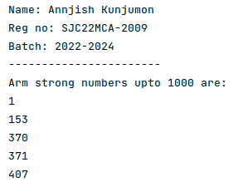

**8. Store and display the days of a week as a List, Tuple, Dictionary, Set. Also demonstrate different ways to store values in each of them. Display its type also.**

**Code:**

print("Name: Annjish Kunjumon")

print("Reg no: SJC22MCA-2009")

print("Batch: 2022-2024")

print("-----------------------")

days_list = ["Monday", "Tuesday", "Wednesday", "Thursday", "Friday", "Saturday", "Sunday"]

print("List:", days_list)

print("Type:", type(days_list))

days_tuple = ("Monday", "Tuesday", "Wednesday", "Thursday", "Friday", "Saturday", "Sunday")

print("Tuple:", days_tuple)

print("Type:", type(days_tuple))

days_dict = {0: "Monday", 1: "Tuesday", 2: "Wednesday", 3: "Thursday", 4: "Friday", 5: "Saturday", 6: "Sunday"}

print("Dictionary:", days_dict)

print("Type:", type(days_dict))

days_set = {"Monday", "Tuesday", "Wednesday", "Thursday", "Friday", "Saturday", "Sunday"}

print("Set:", days_set)

print("Type:", type(days_set))

**Output:**

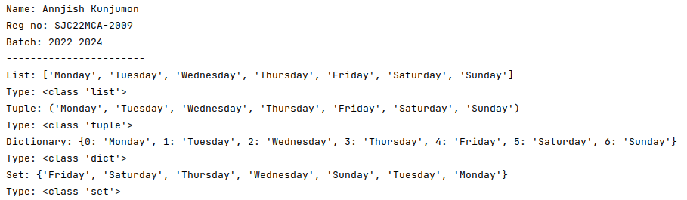

**9. Write a program to add elements of given 2 lists.**

**Code:**

def add_lists(list1, list2):

if len(list1) != len(list2):

return None

result = []

for i in range(len(list1)):

result.append(list1[i] + list2[i])

return result

try:

print("Name: Annjish Kunjumon")

print("Reg no: SJC22MCA-2009")

print("Batch: 2022-2024")

print("-----------------------")

list1 = input("Enter the first list of numbers separated by spaces: ").split()

list1 = [int(x) for x in list1]

list2 = input("Enter the second list of numbers separated by spaces: ").split()

list2 = [int(x) for x in list2]

result = add_lists(list1, list2)

if result is None:

print("The lists have different lengths and cannot be added.")

else:

print("Result of addition:", result)

except ValueError:

print("Invalid input. Please enter valid numbers separated by spaces.")

**Output:**

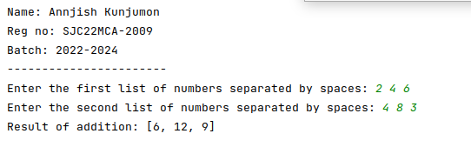

**10. Write a program to find the sum of 2 matrices using nested List.**

**Code:**

def add_matrices(matrix1, matrix2):

if len(matrix1) != len(matrix2) or len(matrix1[0]) != len(matrix2[0]):

return None

result = [[0 for _ in range(len(matrix1[0]))] for _ in range(len(matrix1))]

for i in range(len(matrix1)):

for j in range(len(matrix1[0])):

result[i][j] = matrix1[i][j] + matrix2[i][j]

return result

try:

print("Name: Annjish Kunjumon")

print("Reg no: SJC22MCA-2009")

print("Batch: 2022-2024")

print("-----------------------")

rows = int(input("Enter the number of rows: "))

cols = int(input("Enter the number of columns: "))

print("Enter elements of the first matrix:")

matrix1 = []

for i in range(rows):

row = input(f"Enter elements of row {i + 1} separated by spaces: ").split()

matrix1.append([int(x) for x in row])

print("Enter elements of the second matrix:")

matrix2 = []

for i in range(rows):

row = input(f"Enter elements of row {i + 1} separated by spaces: ").split()

matrix2.append([int(x) for x in row])

result = add_matrices(matrix1, matrix2)

if result is None:

print("Matrix dimensions are not compatible for addition.")

else:

print("Sum of matrices:")

for row in result:

print(" ".join(map(str, row)))

except ValueError:

print("Invalid input. Please enter valid numbers.")

**Output:**

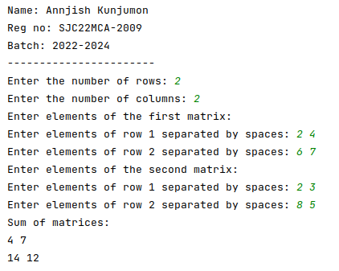

**11. Write a program to perform bubble sort on a given set of elements.**

**Code:**

def bubble_sort(arr):

n = len(arr)

for i in range(n):

swapped = False

for j in range(0, n - i - 1):

if arr[j] > arr[j + 1]:

arr[j], arr[j + 1] = arr[j + 1], arr[j]

swapped = True

if not swapped:

break

try:

print("Name: Annjish Kunjumon")

print("Reg no: SJC22MCA-2009")

print("Batch: 2022-2024")

print("-----------------------")

elements = input("Enter elements separated by spaces: ").split()

elements = [int(x) for x in elements]

bubble_sort(elements)

print("Sorted elements:")

print(elements)

except ValueError:

print("Invalid input. Please enter valid numbers separated by spaces.")

**Output:**

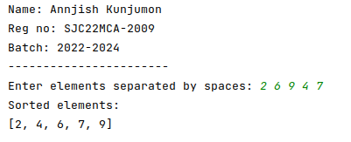

**12. Program to find the count of each vowel in a string(use dictionary).**

**Code:**

def count_vowels(string):

vowel_counts = {'A': 0, 'E': 0, 'I': 0, 'O': 0, 'U': 0}

string = string.upper()

for char in string:

if char in vowel_counts:

vowel_counts[char] += 1

return vowel_counts

try:

print("Name: Annjish Kunjumon")

print("Reg no: SJC22MCA-2009")

print("Batch: 2022-2024")

print("-----------------------")

input_string = input("Enter a string: ")

vowel_counts = count_vowels(input_string)

print("Vowel counts:")

for vowel, count in vowel_counts.items():

print(f"{vowel}: {count}")

except ValueError:

print("Invalid input. Please enter a valid string.")

**Output:**

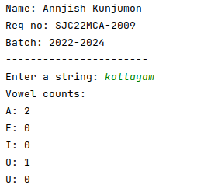

**13. Write a Python program that accept a positive number and subtract from this**

**number the sum of its digits and so on. Continues this operation until the number is positive**

**(eg: 256-&gt;2+5+6=13**

**256-13=243**

**243-9=232……..)**

**Code:**

def sum_of_digits(n):

digit_sum = 0

while n > 0:

digit_sum += n % 10

n //= 10

return digit_sum

try:

print("Name: Annjish Kunjumon")

print("Reg no: SJC22MCA-2009")

print("Batch: 2022-2024")

print("-----------------------")

num = int(input("Enter a positive number: "))

if num <= 0:

print("Please enter a positive number.")

else:

while num > 0:

digit_sum = sum_of_digits(num)

print(f"{num} - {digit_sum} = {num - digit_sum}")

num -= digit_sum

except ValueError:

print("Invalid input. Please enter a valid positive number.")

**Output:**

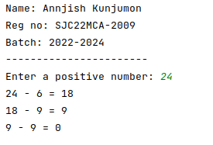

**14. Write a Python program that accepts a 10 digit mobile number, and find the digits which are absent in a given mobile number.**

**Code:**

def find_absent_digits(mobile_number):

all_digits = set("0123456789")

mobile_digits = set(mobile_number)

absent_digits = all_digits - mobile_digits

return sorted(list(absent_digits))

try:

print("Name: Annjish Kunjumon")

print("Reg no: SJC22MCA-2009")

print("Batch: 2022-2024")

print("-----------------------")

mobile_number = input("Enter a 10-digit mobile number: ")

if len(mobile_number) == 10 and mobile_number.isdigit():

absent_digits = find_absent_digits(mobile_number)

if absent_digits:

print("Absent digits in the mobile number:", ', '.join(absent_digits))

else:

print("The mobile number contains all digits from 0 to 9.")

else:

print("Invalid input. Please enter a valid 10-digit mobile number.")

except ValueError:

print("Invalid input. Please enter a valid 10-digit mobile number.")

**Output:**

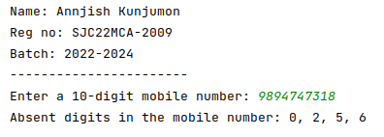

**LAB CYCLE 2**

**1. Create a three dimensional array specifying float data type and print it.**

**Code:**

import numpy as np

print("Annjish Kunjumon")

print("SJC22MCA2009")

print("2022-24")

print("------------------")

x, y, z = 3, 4, 2

array_3d = np.random.rand(x, y, z).astype(float)

print(array_3d)

**Output:**

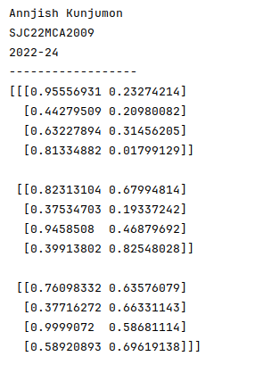

**2. Create a 2 dimensional array (2X3) with elements belonging to complex data type**

**and print it. Also display**

**a. the no: of rows and columns**

**b. dimension of an array**

**c. reshape the same array to 3X2**

**Code:**

import numpy as np

print("Annjish Kunjumon")

print("SJC22MCA2009")

print("2022-24")

print("------------------")

complex_array = np.array([[1+2j, 2+3j, 3+4j],

[4+5j, 5+6j, 6+ 7j]])

print("Complex array:")

print(complex_array)

num_rows, num_cols = complex_array.shape

print(f"Number of rows: {num_rows}")

print(f"Number of columns: {num_cols}")

dimensions = complex_array.shape

print(f"Dimensions of the array: {dimensions}")

reshaped_array = complex_array.reshape(3,2)

print("Reshaped Array:")

print(reshaped_array)

**Output:**

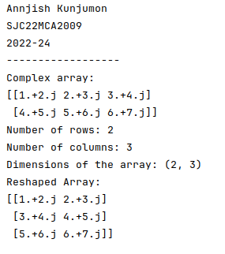

**3. Familiarize with the functions to create**

**a) an uninitialized array**

**b) array with all elements as 1,**

**c) all elements as 0**

**Code:**

import numpy as np

print("Annjish Kunjumon")

print("SJC22MCA2009")

print("2022-24")

print("------------------")

uninitialized_array = np.empty((3, 4))

print("Uninitialized Array:")

print(uninitialized_array)

ones_array = np.ones((2, 3))

print("\nArray with All Elements as 1:")

print(ones_array)

zeros_array = np.zeros((3, 3))

print("\narray with All Elements as 0:")

print(zeros_array)

**Output:**

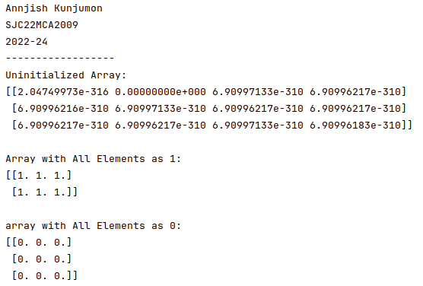

**4. Create an one dimensional array using an arrange function containing 10 elements.**

**Display**

**a. First 4 elements**

**b. Last 6 elements**

**c. Elements from index 2 to 7**

**Code:**

import numpy as np

print("Annjish Kunjumon")

print("SJC22MCA2009")

print("2022-24")

print("------------------")

arr = np.arange(10)

first_4_elements = arr[:4]

print("first 4 elements:", first_4_elements)

last_6_elements = arr[-6:]

print("Last 6 elements:", last_6_elements)

elements_2_to_7 = arr[2:8]

print("Elements from index 2 to 7:", elements_2_to_7)

**Output:**

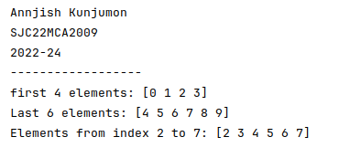

**5. Create an 1D array with arrange containing first 15 even numbers as elements**

**a. Elements from index 2 to 8 with step 2(also demonstrate the same using**

**slice function)**

**b. Last 3 elements of the array using negative index**

**c. Alternate elements of the array**

**d. Display the last 3 alternate elements**

**6. Create a 2 Dimensional array with 4 rows and 4 columns.**

**a. Display all elements excluding the first row**

**b. Display all elements excluding the last column**

**c. Display the elements of 1 st and 2 nd column in 2 nd and 3 rd row**

**d. Display the elements of 2 nd and 3 rd column**

**e. Display 2 nd and 3 rd element of 1 st row**

**f. Display the elements from indices 4 to 10 in descending order(use**

**–values)**

**Code:**

import numpy as np

print("Annjish Kunjumon")

print("SJC22MCA2009")

print("2022-24")

print("------------------")

arr = np.arange(2, 32, 2)

slice_a = arr[2:9:2]

last_3_elements = arr[-3:]

alternate_elements = arr[::2]

last_3_alternate_elements = alternate_elements[-3:]

print("Original Array:", arr)

print("a. Elements from index 2 to 8 with step 2:", slice_a)

print("b. Last 3 elements of the array using negative index:", last_3_elements)

print("c. Alternate elements of the array:", alternate_elements)

print("d. Last 3 alternate elements:", last_3_alternate_elements)

**Output:**

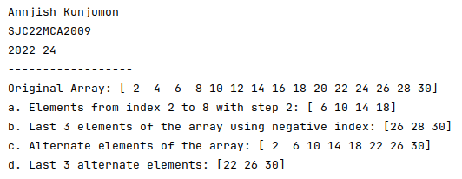

**6. Create a 2 Dimensional array with 4 rows and 4 columns.**

**a. Display all elements excluding the first row**

**b. Display all elements excluding the last column**

**c. Display the elements of 1 st and 2 nd column in 2 nd and 3 rd row**

**d. Display the elements of 2 nd and 3 rd column**

**e. Display 2 nd and 3 rd element of 1 st row**

**f. Display the elements from indices 4 to 10 in descending order(use**

**–values)**

**Code:**

import numpy as np

array_2d = np.array([[1, 2, 3, 4],

[5, 6, 7, 8],

[9, 10, 11, 12],

[13, 14, 15, 16]])

print("Annjish Kunjumon")

print("SJC22MCA2009")

print("2022-24")

print("------------------")

print("All elements excluding the first row:")

print(array_2d[1:, :])

print("\nAll elements excluding the last column:")

print(array_2d[:, :-1])

print("\nElements of the 1st and 2nd column in the 2nd and 3rd row:")

print(array_2d[1:3, 0:2])

print("\nElements of the 2nd and 3rd column:")

print(array_2d[:, 1:3])

print("\n2nd and 3rd element of the 1st row:")

print(array_2d[0, 1:3])

print("\nElements from indices 4 to 10 in descending order:")

print(array_2d.flatten()[10:3:-1])

**Output:**

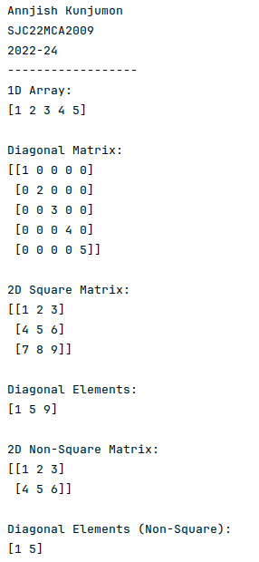

**7. Create two 2D arrays using array object and**

**a. Add the 2 matrices and print it**

**b. Subtract 2 matrices**

**c. Multiply the individual elements of matrix**

**d. Divide the elements of the matrices**

**e. Perform matrix multiplication**

**f. Display transpose of the matrix**

**g. Sum of diagonal elements of a matrix**

**Code:**

import numpy as np

matrix1 = np.array([[1, 2, 3],

[4, 5, 6],

[7, 8, 9]])

matrix2 = np.array([[9, 8, 7],

[6, 5, 4],

[3, 2, 1]])

print("Annjish Kunjumon")

print("SJC22MCA2009")

print("2022-24")

print("------------------")

addition_result = matrix1 + matrix2

print("Matrix addition:")

print(addition_result)

subtraction_result = matrix1 - matrix2

print("\nMatrix Subtraction:")

print(subtraction_result)

multiplication_result = matrix1 * matrix2

print("\nMatrix Element-wise Multiplication:")

print(multiplication_result)

division_result = matrix1 / matrix2

print("\nMatrix Element-wise Division:")

print(division_result)

matrix_multiplication_result = np.dot(matrix1, matrix2)

print("\nMatrix Multiplication:")

print(matrix_multiplication_result)

matrix1_transpose = np.transpose(matrix1)

print("\nTranspose of Matrix1:")

print(matrix1_transpose)

diagonal_sum = np.trace(matrix1)

print("\nSum of Diagonal Elements:")

print(diagonal_sum)

**Output:**

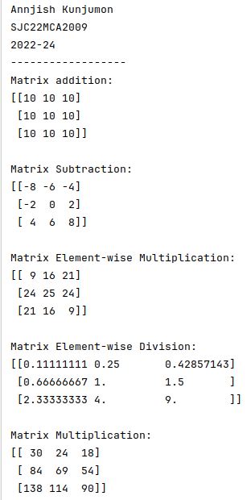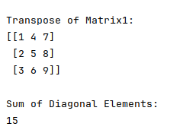

**8. Demonstrate the use of insert() function in 1D and 2D array.**

**Code:**

print("Annjish Kunjumon")

print("SJC22MCA2009")

print("2022-24")

print("------------------")

my_list = [1, 2, 3, 4, 5]

my_list.insert(2, 10)

print(my_list)

print("--------------------------")

my_2d_array = [

[1, 2, 3],

[4, 5, 6],

[7, 8, 9]

]

element_to_insert = 10

row_index = 1

column_index = 1

my_2d_array[row_index].insert(column_index, element_to_insert)

for row in my_2d_array:

print(row)

**Output:**

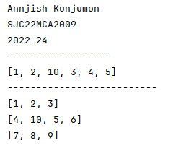

**9. Demonstrate the use of diag() function in 1D and 2D array.(use both square matrix and matrix with different dimensions).**

**Code:**

import numpy as np

print("Annjish Kunjumon")

print("SJC22MCA2009")

print("2022-24")

print("------------------")

arr_id = np.array([1, 2, 3, 4, 5])

diagonal_matrix = np.diag(arr_id)

print("1D Array:")

print(arr_id)

print("\nDiagonal Matrix:")

print(diagonal_matrix)

arr_2d_square = np.array([[1, 2, 3],

[4, 5, 6],

[7, 8, 9]])

diagonal_elements = np.diag(arr_2d_square)

print("\n2D Square Matrix:")

print(arr_2d_square)

print("\nDiagonal Elements:")

print(diagonal_elements)

arr_2d_non_square = np.array([[1, 2, 3],

[4, 5, 6]])

diagonal_elements_non_square = np.diag(arr_2d_non_square)

print("\n2D Non-Square Matrix:")

print(arr_2d_non_square)

print("\nDiagonal Elements (Non-Square):")

print(diagonal_elements_non_square)

**Output:**

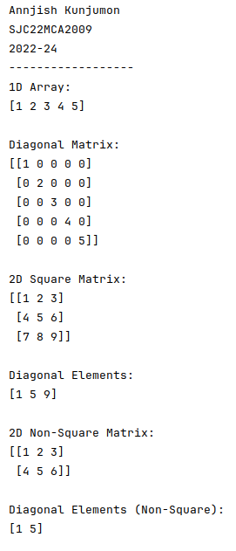

**10. Create a square matrix with random integer values(use randint()) and use**

**appropriate functions to find:**

**i) inverse**

**ii) rank of matrix**

**iii) Determinant**

**iv) transform matrix into 1D array**

**v) eigenvalues and vectors**

**Code:**

import numpy as np

print("Annjish Kunjumon")

print("SJC22MCA2009")

print("2022-24")

print("------------------")

matrix_size = 3

matrix = np.random.randint(1, 10, size=(matrix_size, matrix_size))

print("Original Matrix:")

print(matrix)

if np.linalg.matrix_rank(matrix) == matrix_size:

inverse_matrix = np.linalg.inv(matrix)

print("\nInverse Matrix:")

print(inverse_matrix)

else:

print("\nThe matrix is not invertible (its rank is less than the size).")

rank = np.linalg.matrix_rank(matrix)

print("\nRank of the Matrix:", rank)

determinant = np.linalg.det(matrix)

print("\nDeterminant of the Matrix:", determinant)

matrix_1d = matrix.flatten()

print("\nMatrix as 1D Array:")

print(matrix_1d)

eigenvalues, eigenvectors = np.linalg.eig(matrix)

print("\nEigenvalues:")

print(eigenvalues)

print("\nEigenvectors:")

print(eigenvectors)

**Output:**

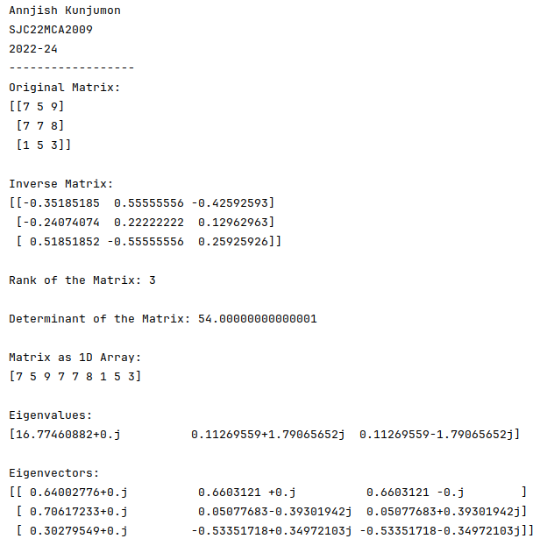

**11. Create a matrix X with suitable rows and columns**

**i) Display the cube of each element of the matrix using different**

**methods(use multiply(), *, power(),**)**

**ii) Display identity matrix of the given square matrix.**

**iii) Display each element of the matrix to different powers.**

**Code:**

import numpy as np

print("Annjish Kunjumon")

print("SJC22MCA2009")

print("2022-24")

print("------------------")

X = np.array([[1, 2,3 ],

[4, 5, 6],

[7, 8, 9]])

X_cube_multiply = np.multiply(X, np.multiply(X, X))

X_cube_operator = X * X * X

X_cube_power = np.power(X, 3)

X_cube_double_star = X ** 3

identity_matrix = np.identity(X.shape[0])

X_power_2 = np.power(X, 2)

X_power_3 = np.power(X, 3)

X_power_4 = np.power(X, 4)

print("Original Matrix X:")

print(X)

print("\nCubed Matrix (Method 1 - multiply()):")

print(X_cube_multiply)

print("\nCubed Matrix (Method 2 - * operator):")

print(X_cube_operator)

print("\nCubed Matrix (Method 3 - power()):")

print(X_cube_power)

print("\nCubed Matrix (Method 4 - ** operator):")

print(X_cube_double_star)

print("\nIdentity Matrix:")

print(identity_matrix)

print("\nMatrix to Different Powers:")

print("X^2:")

print(X_power_2)

print("\nX^3:")

print(X_power_3)

print("\nX^4:")

print(X_power_4)

**Output:**

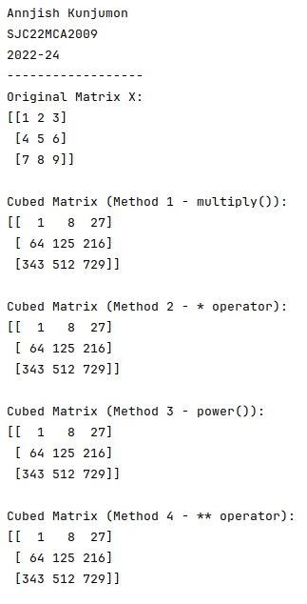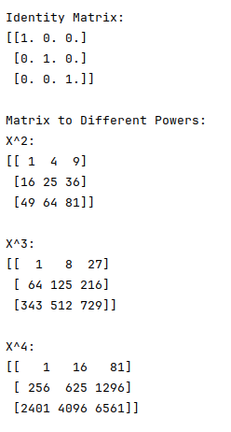

**11b. Create a matrix Y with the same dimension as X and perform the operation X 2 +2Y.**

**Code:**

import numpy as np

print("Annjish Kunjumon")

print("SJC22MCA2009")

print("2022-24")

print("------------------")

X = np.array([[1, 2],

[3, 4]])

Y = np.random.rand(*X.shape)

result = X * 2 + 2 * Y

print(result)

**Output:**

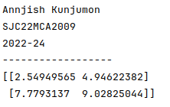

**12. Define matrices A with dimension 5x6 and B with dimension 3x3.**

**Extract a sub matrix of dimension 3x3 from A and multiply it with B. Replace the**

**extracted sub matrix in A with the matrix obtained after multiplication.**

**Code:**

import numpy as np

print("Annjish Kunjumon")

print("SJC22MCA2009")

print("2022-24")

print("------------------")

print()

A = np.array([[1, 2, 3, 4, 5, 6],

[7, 8, 9, 10, 11, 12],

[13, 14, 15, 16, 17, 18],

[19, 20, 21, 22, 23, 24],

[25, 26, 27, 28, 29, 30]])

B = np.array([[2, 3, 4],

[5, 6, 7],

[8, 9, 10]])

submatrix_A = A[:3, :3]

result = np.dot(submatrix_A, B)

A[:3, :3] = result

*# Display the updated matrix A*

print("Updated Matrix A:")

print(A)

**Output:**

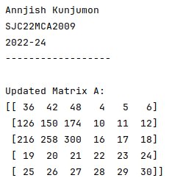

**13. Given 3 Matrices A, B and C. Write a program to perform matrix multiplication of the 3 matrices.**

**Code:**

import numpy as np

print("Annjish Kunjumon")

print("SJC22MCA2009")

print("2022-24")

print("------------------")

A = np.array([[1, 2, 3],

[4, 5, 6]])

B = np.array([[7, 8],

[9, 10],

[11, 12]])

C = np.array([[13, 14],

[15, 16]])

result = np.matmul(np.matmul(A, B), C)

print("Result of matrix multiplication:")

print(result)

**Output:**

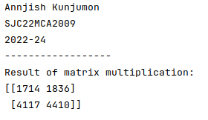

**14. Write a program to check whether given matrix is symmetric or Skew Symmetric.**

**Code:**

import numpy as np

print("Annjish Kunjumon")

print("SJC22MCA2009")

print("2022-24")

print("------------------")

*# Function to check if a matrix is symmetric*

def is_symmetric(matrix):

return np.array_equal(matrix, matrix.T)

*# Function to check if a matrix is skew-symmetric*

def is_skew_symmetric(matrix):

return np.array_equal(matrix, -matrix.T)

*# Input matrix dimensions*

rows = int(input("Enter the number of rows: "))

cols = int(input("Enter the number of columns: "))

*# Initialize an empty matrix*

matrix = np.zeros((rows, cols))

print("Enter matrix elements row by row:")

for i in range(rows):

row = input().split()

for j in range(cols):

matrix[i][j] = float(row[j])

*# Check if the matrix is symmetric or skew-symmetric*

if is_symmetric(matrix):

print("The matrix is symmetric.")

elif is_skew_symmetric(matrix):

print("The matrix is skew-symmetric.")

else:

print("The matrix is neither symmetric nor skew-symmetric.")

**Output:**

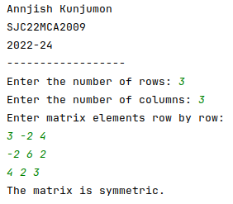

**15. Given a matrix-vector equation AX=b. Write a program to find out the value of X**

**using solve(), given A and b as below**

**X=A -1 b.**

**Code:**

import numpy as np

print("Annjish Kunjumon")

print("SJC22MCA2009")

print("2022-24")

print("------------------")

A = np.array([[2, 1, -2],

[3, 0, 1],

[1, 1, -1]])

b = np.array([[-3],

[5],

[-2]])

try:

X = np.linalg.solve(A, b)

print("Solution X:")

print(X)

except np.linalg.LinAlgError:

print("Matrix A is singular. The system of equations may not have a unique solution.")

**Output:**

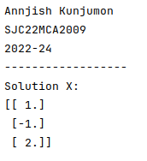

**16. Write a program to perform the SVD of a given matrix A. Also reconstruct the given matrix from the 3 matrices obtained after performing SVD.**

**Use the function: numpy.linalg.svd()**

**Singular value Decomposition**

**Matrix decomposition, also known as matrix factorization, involves describing a given matrix using its constituent elements.**

**The Singular-Value Decomposition, or SVD for short, is a matrix decomposition method for reducing a matrix to its constituent parts in order to make certain subsequent matrix calculations simpler. This approach is commonly used in reducing the no: of attributes in the given data set.**

**The SVD of mxn matrix A is given by the formula**

**Code:**

import numpy as np

print("Annjish Kunjumon")

print("SJC22MCA2009")

print("2022-24")

print("------------------")

A = np.array([[5, 27, 32], [14, 53, 62], [67, 88, 19]])

U, S, Vt = np.linalg.svd(A)

A_hat = U @ np.diag(S) @ Vt

print("Original Matrix A:")

print(A)

print("\nSingular Values:")

print(S)

print("\nReconstructed Matrix A_hat:")

print(A_hat)

**Output:**

